Geometry: Unit 6, Lesson 11

- Solve the equation $9x-24=6x-12$ for $x$.

$$4$$

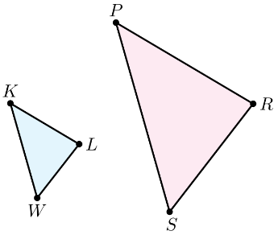
- Triangles $KLW$ and $SRP$ are shown where $∆KLW \sim ∆PRS$. If $PR=4$ and the scale factor of $∆PRS$ to $∆KLW$ is $\frac{1}{2}$, what is the measurement of $KL$?

$$2$$
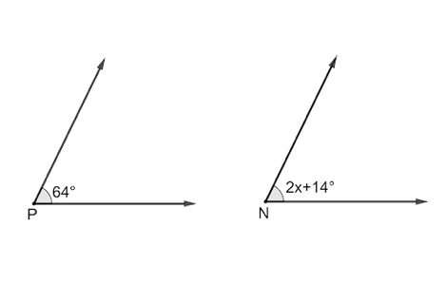
- Angles $P$ and $N$ are shown, where $∠P≅∠N$. What is the value of $x$?

$x=25$

